Desktop page is kept logged in, instead of cancelling page and opening on fresh page.

No registration verification is done through Email.

No mobile number prompted for sms OTP.

“Remember Me” option is not working.

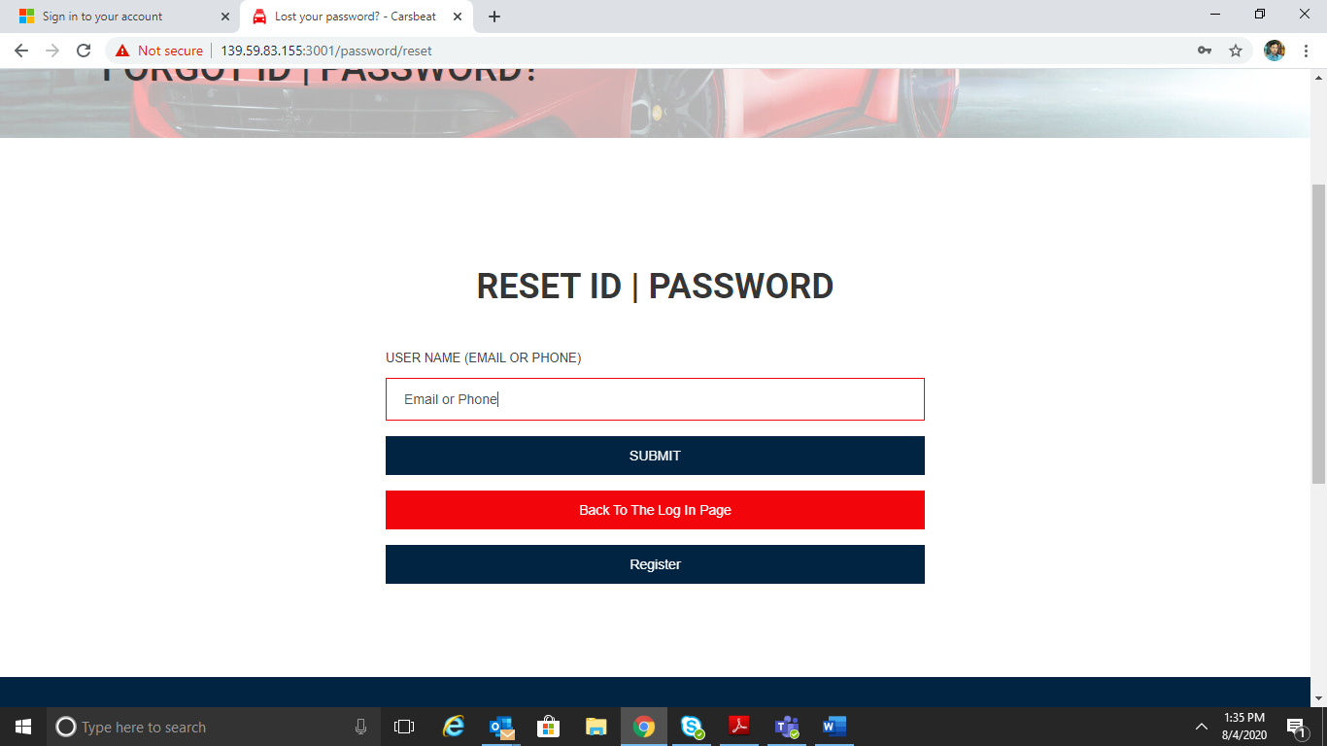
2
1

1 – This text is editable?!
2 – Reset ID?!
No email sent for Reset Password.

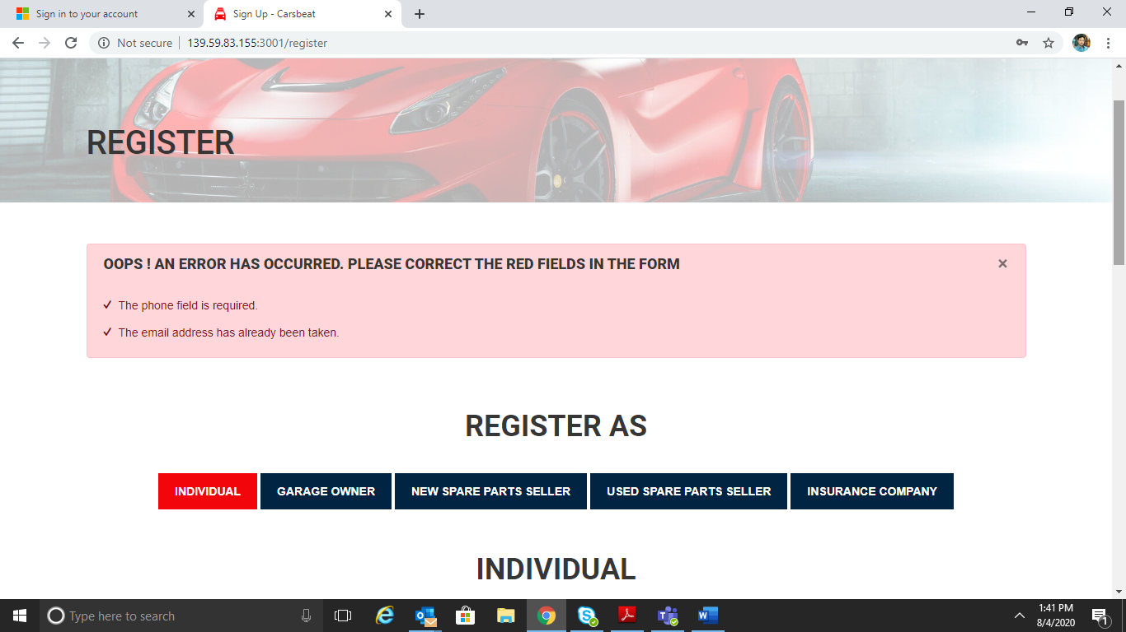
1

1 # instead of “Phone field”, can we amend to read as “Mobile number field”.

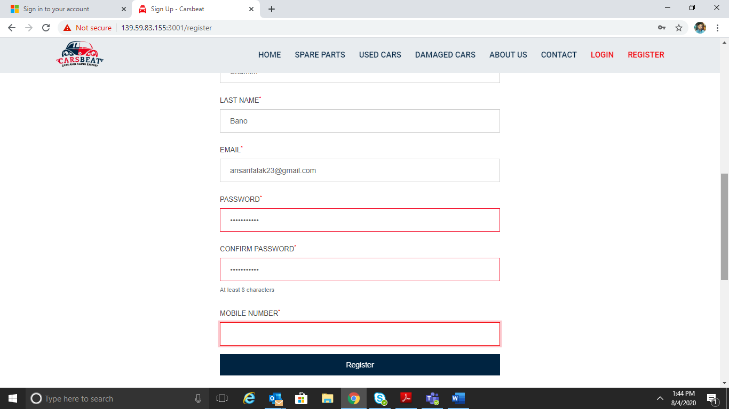
1

1 # can we have country code option as well. This will be required for the people registering from outside the UAE.

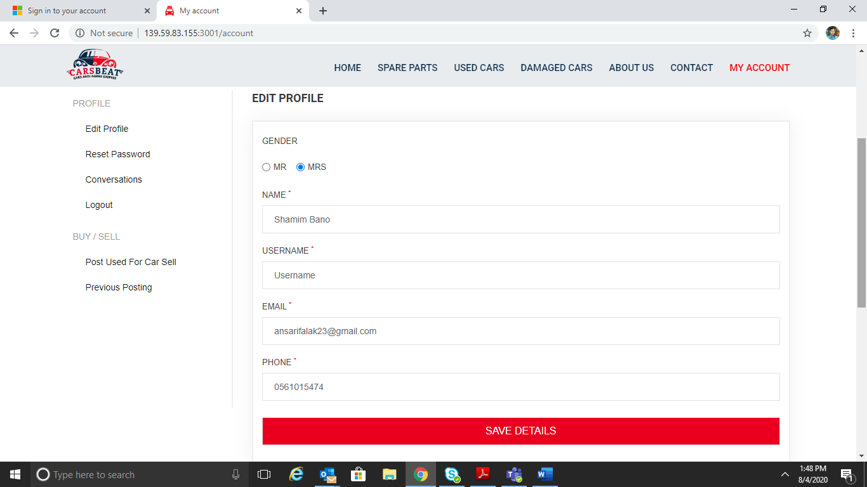
1
1# Can we add more Gender options such as “Miss”.

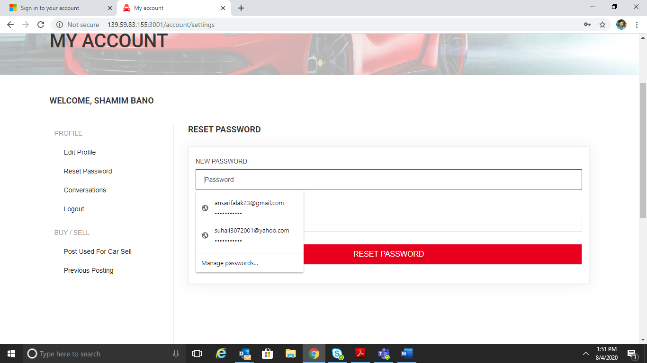
1

1 # In resent password feature, account ID is appearing.!

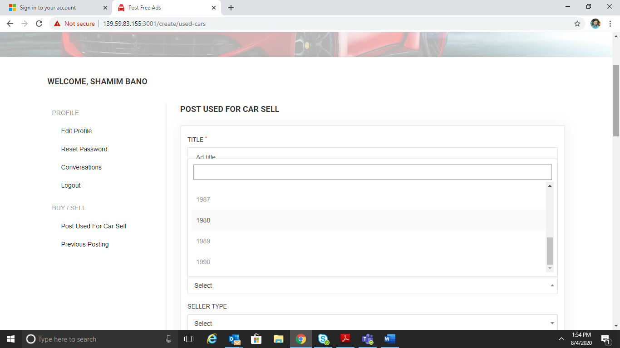
1

1 # Dropdown is carrying 10 number of years only. Manual entry is also prohibited.

Can you please darken or change the colour of selected item. It is difficult to recognize which option is selected.

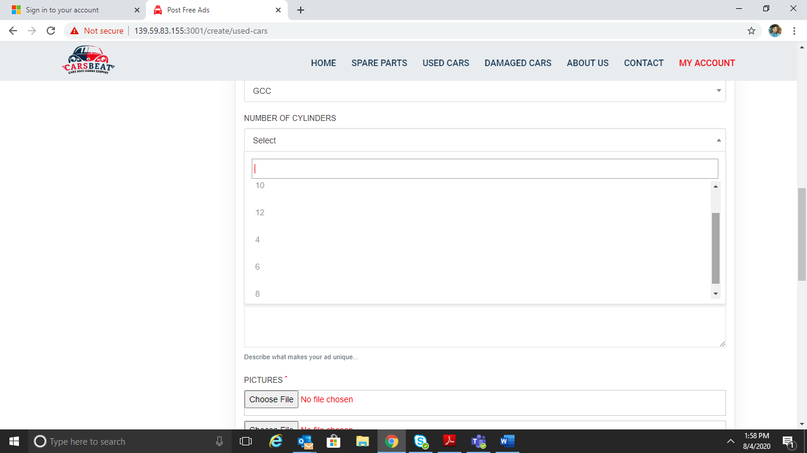
1

1 # Please mention the number in Serial Order.

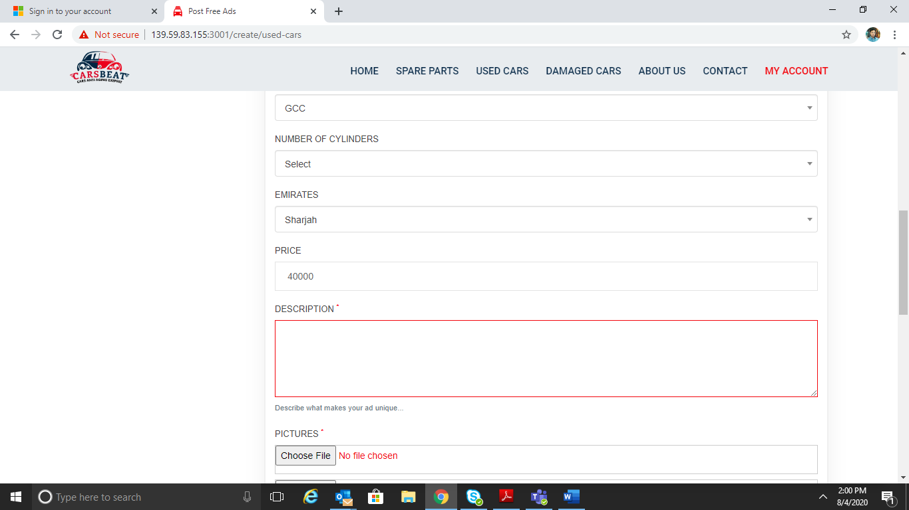
2
1
1 # Please mentioned currency – Price (AED.)
2 # Please use 1,000 separator (,)
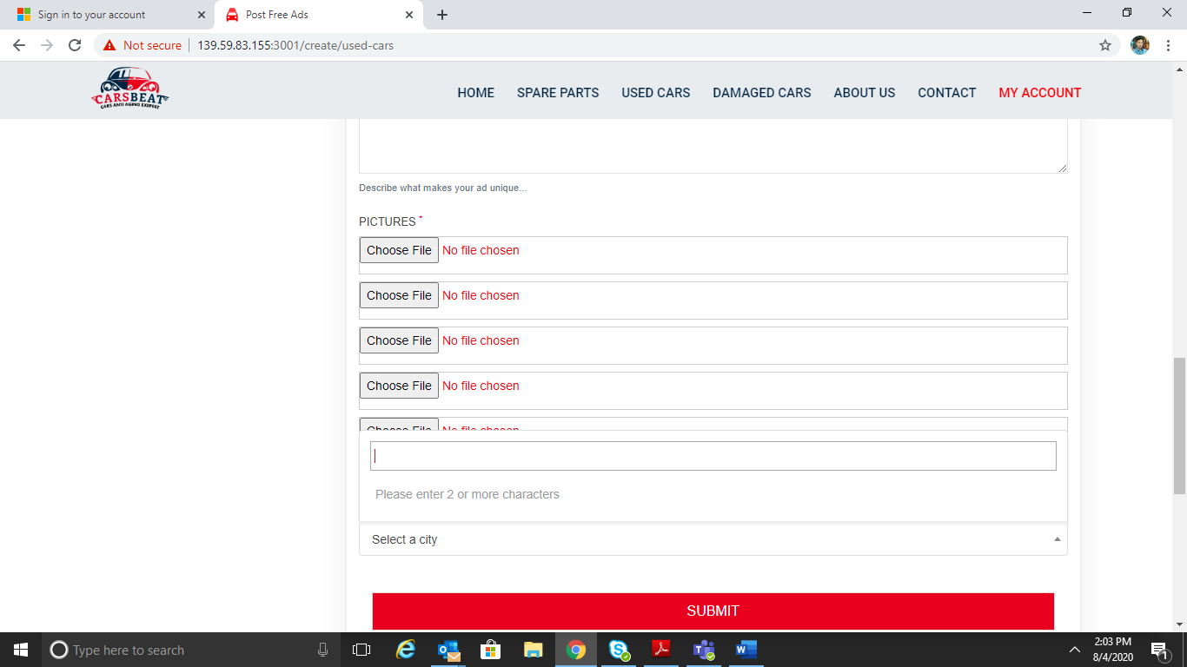
1

1 # Heading disappears when page is moved up and down through bar

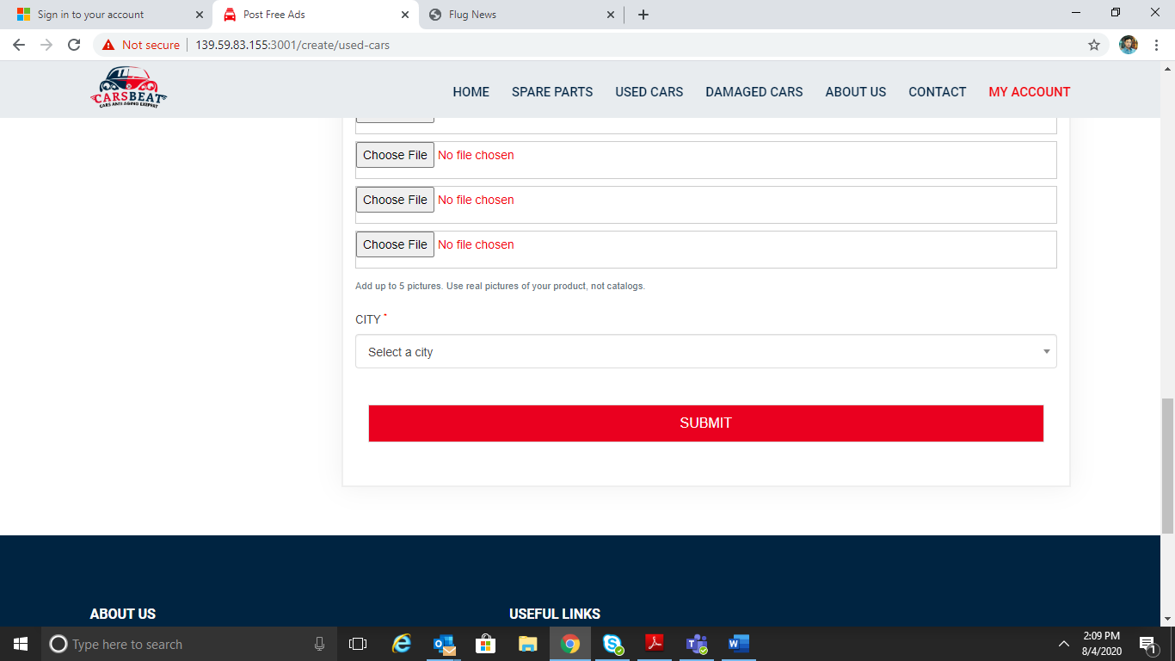
1
1 # Should we put CITY or LOCATION?

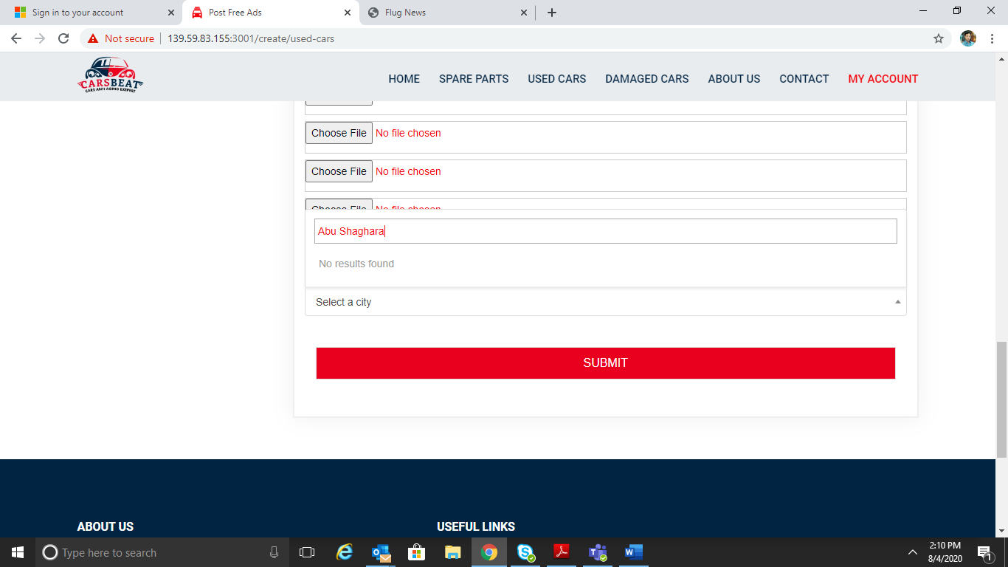
1
1 # this seems mandatory field. Even if it is, name should be mentioned manually or location is selected through map. Name is not able to be entered.

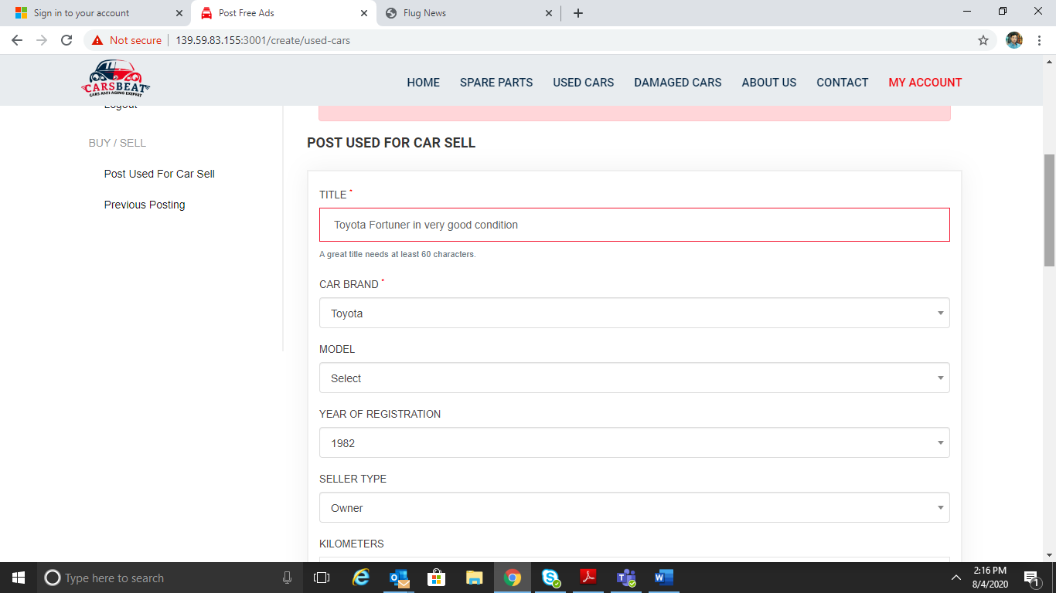
3
2
1
1 # It should be “Post Used Car for Sale”.
2 # Should be “Car Make”
3 # Should be “Year of Manufacture”

Since CITY is mandatory yet disabled, not able to proceed further on this option.

